

Sk8CreteOrBot – photo publish flow

1. Navigate to User Login Landing Page [http://seattlerules.com/cellphoto/facebstestepookpost.php](http://seattlerules.com/cellphoto/facebookpost.php)

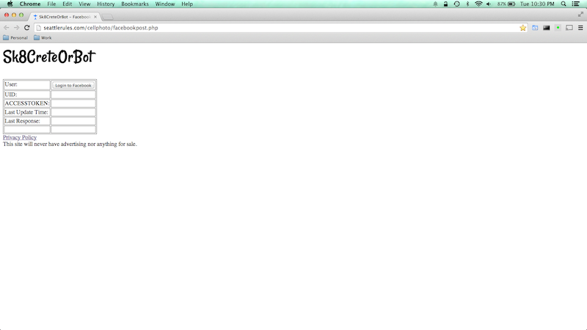

1. Click the Login button

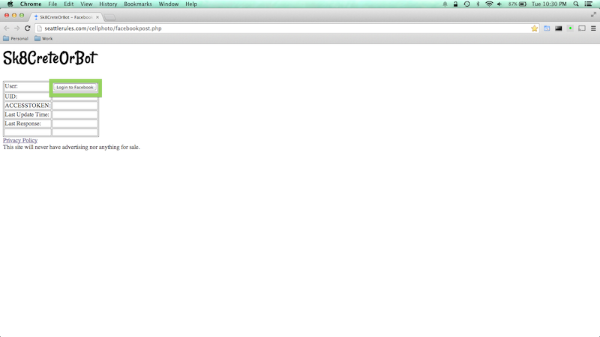

1. Login through the Facebook Login Popup

|  |  |
| --- | --- |
| UID | stu_dfoxorp_stuverson@tfbnw.net |
| PWD | Test@Test1 |

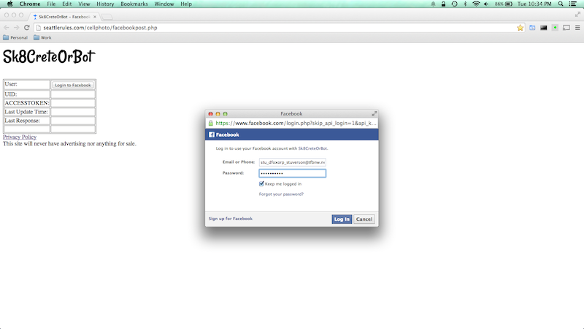

1. Sk8creteorbot status monitor appears.

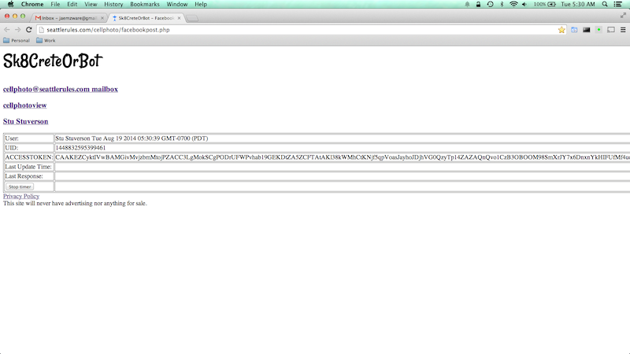

1. Wait 10 seconds for status monitor to display its first update. When that occurs, you will see the “Last Update Time” and “Last Reponse” table cells populate with values.

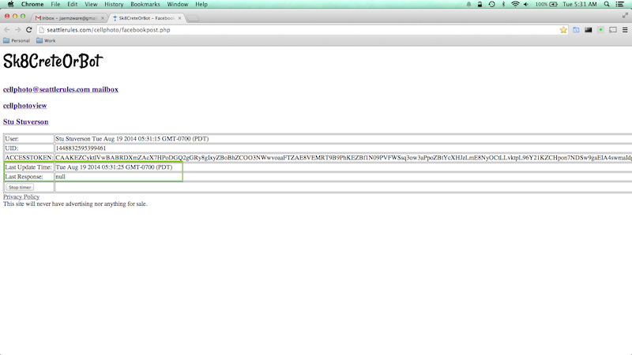

1. Send an email with a jpg image attachment to [cellphoto@seattlerules.com](mailto:cellphoto@seattlerules.com). Other supported formats are:. .mov, .m4a, .gif, .3gp, .png, and .mp4; however, only .jpg, .gif, and .png will display as images on Facebook. All others will show up as links.

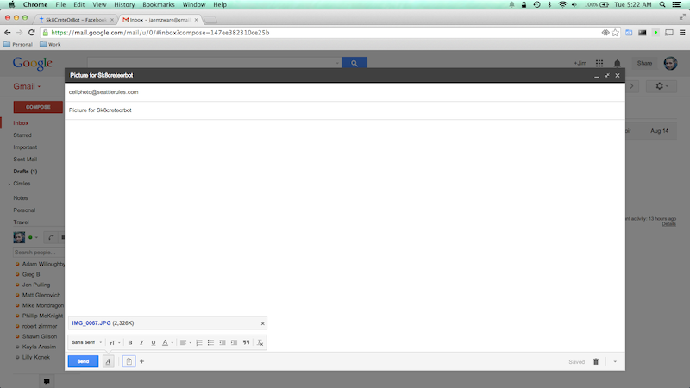

1. Wait for image attachment to be processed by status monitor.

At this point, the image has been:

* 1. posted to http://seattlerules.com/cellphoto/cellphotoview.php
  2. posted to a Facebook photo album named “Sk8CreteOrBot Photos” for Sk8CreteOrBot authenticated user.

